Doc. 10452

8 February 2005

The rights of children in institutions: follow-up to Recommendation 1601 (2003) of the Parliamentary Assembly

Report

Social, Health and Family Affairs Committee
Rapporteur : Mr Michael Hancock, United Kingdom, Liberal, Democratic and Reformers’ Group

Summary

In some areas of Europe, children’s rights go no further than the doorsteps of sinister, dilapidated buildings lost in the backwoods where children live in reclusion, often in their hundreds.

Anyone who has seen these abandoned, often disabled, children, shut away in insanitary buildings under intolerable conditions with no treatment, knows what the words “children in institutions” really mean.

For people who have seen this, de-institutionalisation is a priority.

De-institutionalisation must, of course, be complemented by welfare measures and financial assistance for families and by alternatives to institutions aimed at preventing abandonment and reintegrating children into family life, the community and, later on, the world of work.

However, de-institutionalisation does have its limits. Institutions for children will always exist because they are necessary. Another aim, therefore, should be to give them a human face.

This process of de-institutionalisation and the rehabilitation of institutions cannot be successful without the support and, in particular, the financial backing of the international community which must not slacken in its efforts despite the immensity of the task. It must continue them in order to avoid wiping out the progress already made. It must also check that its funds are going to the right places and are being used for the right purposes.

I. Draft recommendation

1. The Parliamentary Assembly draws attention to the content of its previous Recommendation 1601 (2003) on improving the lot of abandoned children in institutions adopted in April 2003 and reaffirms the relevance and current validity of the various recommendations and proposals to member states and to the Committee of Ministers of the Council of Europe contained in that text.

2. The Assembly takes note with satisfaction of the reply to its proposals by the Committee of Ministers of the Council of Europe (Doc. 9939) which is currently preparing a recommendation on this issue for the member states. It sees this as expressing a political desire to give the rights of children living in institutions appropriate weight and priority. It also takes note of the various forms of financial support provided by the Council of Europe Development Bank for member states which are de-institutionalising abandoned children and setting up alternative forms of care for them.

3. It points out that maximum priority must be given to de-institutionalising children, closing insanitary and dilapidated institutions and renovating others when possible. De-institutionalisation must be complemented by welfare measures and benefits to help children to reintegrate families and by alternatives to institutions. However, the aim is not to empty institutions at all costs, since some children will always need institutional care.

4. The Assembly stresses that the problem of children living in institutions is common to all member states of the Council of Europe and that no member state can claim to be beyond criticism in this field. However, one cannot fail to notice that in some member states, and especially in the recent post-communist democracies, the situation of such children is still particularly disturbing and necessitates further substantial progress.

5. In those countries, despite the undeniable positive changes that have come about, abandonment and placement in institutions for children, particularly those with disabilities, are still continuing owing to the problems, primarily of an economic nature, faced by families, the absence or inadequacy of social benefits and the difficulty of changing people’s attitudes; the victims of such practices are very often children from ethnic minorities.

6. The Assembly welcomes the fact that the upcoming accession to the European Union of certain candidate countries has put the political spotlight on the plight of children in institutions and that funds are being devoted to improving it. However, this assistance will shortly be discontinued and it questions the political will and ability of these countries to take over the task and consolidate and build on the progress made.

7. It is also concerned about the number and the fate of children in institutions in other European countries which are not European Union applicant states. The fate of children in institutions has ceased to be a matter for the social welfare field and has now become first and foremost a human rights issue which gives the Council of Europe an important role in this respect.

8. The Assembly therefore recommends that the Committee of Ministers of the Council of Europe:

i. expedite the work of preparing and adopting the draft Recommendation on the rights of children living in institutions and provide for a mechanism to supervise the implementation of this Recommendation;

ii. add the rights of children living in institutions to the subjects covered by the thematic monitoring report;

iii. develop intergovernmental co-operation programmes for children in institutions, addressing the development of alternatives to institutionalisation, family and social policy measures for families aimed at preventing abandonment and the integration into society and the world of work of young adults who have spent their whole lives in institutions;

iv. ask the member states to create, at national level, a central authority responsible for children in institutions and for their rights, empowered to issue guidelines on the requisite policy in full knowledge of the issues and capable of preventing duplication, incoherence and waste of resources;

v. make an urgent appeal to sponsors throughout the international community – European and international institutions, NGOs, etc – to continue their financial efforts on behalf of children in institutions;

vi. urge sponsors and the European Union in particular to ensure that European funds granted to the various European states for children in institutions actually reach their proper destination and to regularly verify the use of such funds.
II. Explanatory memorandum by Mr Hancock

A. General comments

1. In April 2003 the Parliamentary Assembly adopted a first report on “improving the lot of abandoned children in institutions” (Doc. 9692 and Recommendation 1601 (2003)) and Order No. 587 (2003), which mandated the Social, Health and Family Affairs Committee to “give appropriate follow-up to the issues raised … and to report by the end of 2004 to the Assembly on the progress made in the different member States”.

2. Owing to the time-scale imposed, this new report is confined to two States only, namely Romania (Part B) and Bulgaria (Part C). The Rapporteur stresses that it is not a case of pointing the finger at these two countries only. The issue of children in institutions is common to all Council of Europe member States, none of which can claim to be above criticism in this field. However, the situation of such children in some new member States is in particular need of improvement. (See Appendix 1, particularly tables (8.1), (8.2) and (8.3) on children in central and eastern Europe, Unicef, Innocenti Social Monitor 2004, English only).

3. So, for lack of time the Rapporteur has had to cut down on the number of visits conducted. The Rapporteur could usefully have visited institutions throughout Russia, Moldova, Albania… and innumerable other States.

4. The list is not exhaustive. One of the specific features of the two countries selected is that they will probably soon be prospective members of the European Union, which turns the political spotlight on to the situation of children in institutions; their opposite numbers in many other European countries are less fortunate!

5. The Rapporteur feels that it is vital to take effective action on texts adopted by the Assembly, particularly in the social field, if its recommendations and resolutions are really to be meaningful. The Rapporteur considers that such follow-up action should not be confined to the often rather conventional replies by the Committee of Ministers of the Council of Europe. In this particular case, however, the reply of the Committee of Ministers to the aforementioned Recommendation 1601 (2003) (see Doc. 9939) informs us that a draft recommendation on the subject is currently being prepared for the attention of all member States. This initiative is to be welcomed, and we must hope that the recommendation will be swiftly adopted, even if such a text is not binding.

6. The general conclusions which the Rapporteur can draw from the report are similar to all the previous ones. Real change requires a genuine political will and a high level of financial resources. However, as the Rapporteur noted during his visits, a system is needed to monitor the destination and utilisation of funds in the short- to medium-term, which system would unfortunately seem to be lacking. We must prioritise deinstitutionalisation, identify alternative modes of provision for children and introduce family assistance policies aimed at preventing children from being abandoned. One further priority which is often underestimated is the integration into society and employment of young adults leaving the institutions who have never known any other way of life.

7. The Rapporteur would endeavour to ensure that this type of picture (SERA photograph) taken at the end of the 20th century irreversibly becomes a thing of the past in Europe, and would like to be certain that this will be the case.

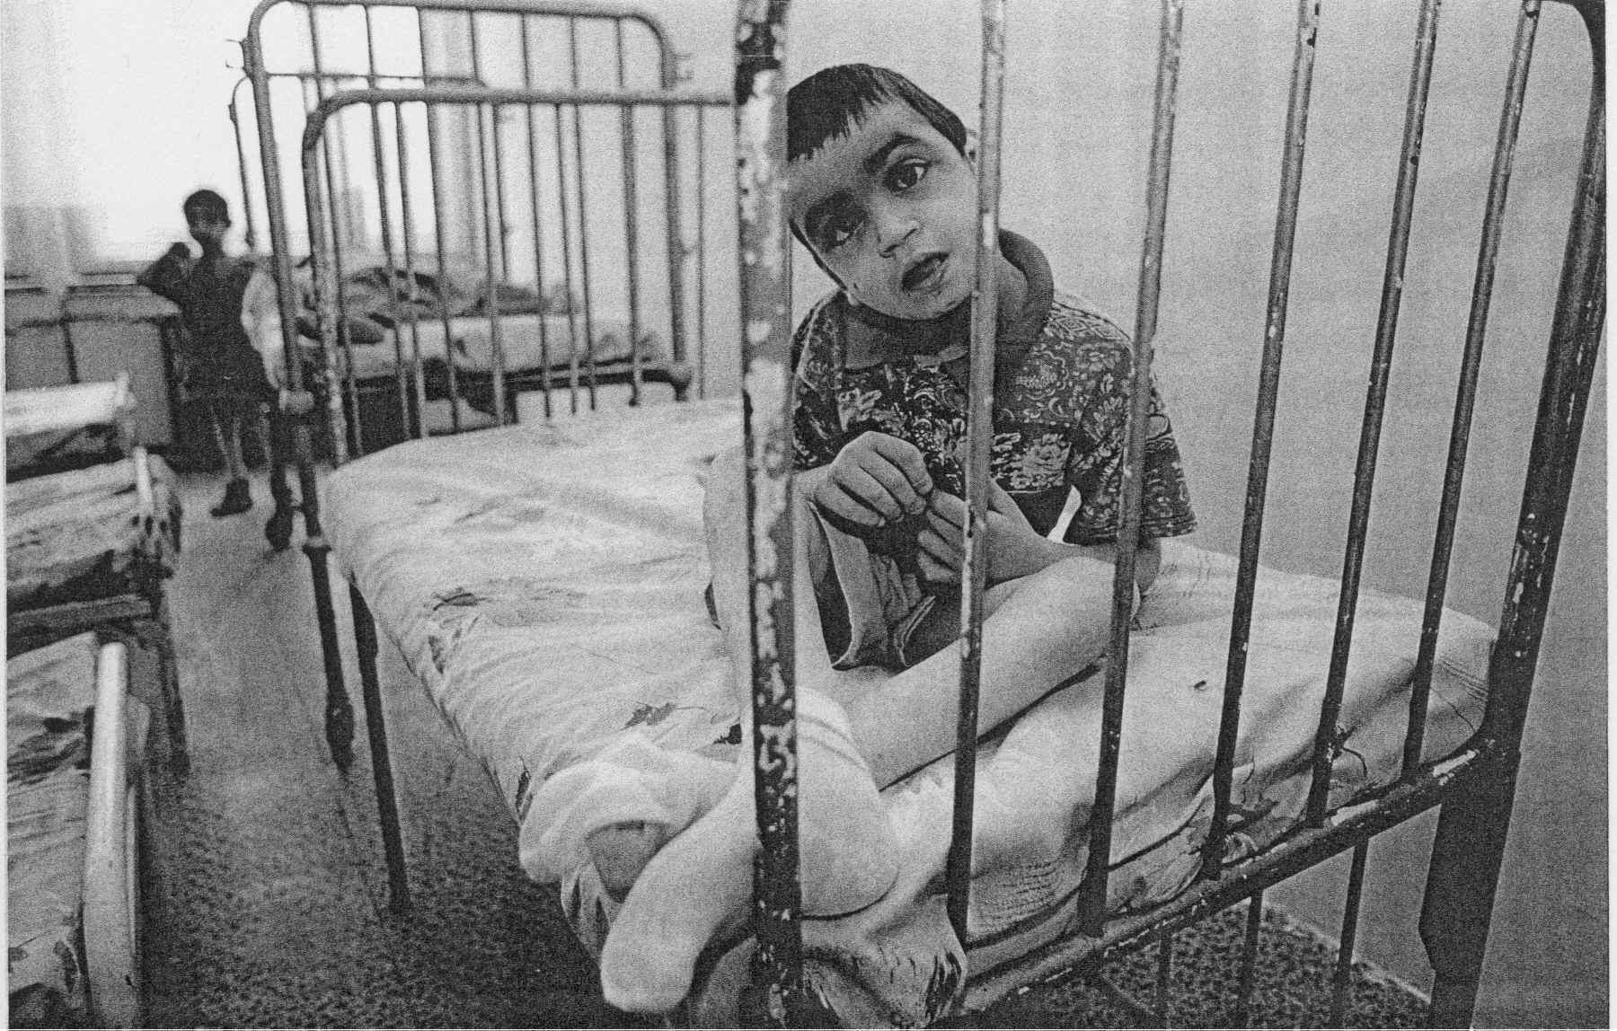

B. Memorandum on the visit to Romania (4-7 April 2004)

I. Introduction

1. This visit was carried out from 4 to 7 April 2004, with the able assistance of the secretariat of the Romanian delegation to the Parliamentary Assembly. The rapporteur wishes to thank Ms Nadia Ionescu. He also wishes to thank his colleagues in the Romanian parliamentary delegation, in particular Mrs Cliveti, member of the Social Affairs Committee and the Romanian authorities for kindly agreeing to be interviewed by him. He further wishes to express his appreciation to the various institutions which he visited and also to the host families and children, for answering his questions.

2 Appendix 2 contains the programme for the rapporteur’s visit and Appendix 3 a list of institutions that are due to be closed down in Romania.

3. The brand new draft law on the protection of children’s rights and the new rules on adoption, currently before Parliament, are the result of two years’ work. The primary responsibility for children lies with parents but the state has a duty to help families.

4. Responsibility for child welfare is spread over a large number of government agencies. At national level, operating under the wing of the Ministry of Labour, the National Authority for Child Protection (headed by the State Secretary, Ms Coman) has primary responsibility for implementing the governmental strategy for the protection of children in difficulty (before, responsibility for children with
disabilities lay with the State Secretary for the disabled). At local level, the mayor and the County Council, operating through various subordinate institutions, play a vital role in deciding what action should be taken and in allocating resources.

II. Child welfare: a political priority

5. The issue of child welfare has become a political priority. The Prime Minister and his cabinet have made a political commitment in this area. Two years ago, each member of the Social Democratic Party agreed to take charge of a certain number of orphanages, which they visit on a regular basis.

6 Since 1990, the issue of children in institutions has been addressed as part of the wider concern for child welfare. The period 1990-97 saw NGOs begin to play a pioneering role in this field. 1994 saw the emergence of the first social workers and in 1998, the system of foster families was introduced. Today there are 12,000 such families. The emphasis now is on family-based care.

7. Since 2001 and thanks mainly to European Union assistance, the number of children in institutions has fallen significantly and institutions have been closed down in favour of alternative arrangements, in particular family-based care. According to the Romanian authorities, over 100 institutions have been shut down. See in Appendix 2 the list of thirty institutions which are due to be closed under the Phare programme. The head of the National Authority for Child Protection, Ms Coman, puts the number of Romanian children in state-run and private institutions at 37,000, out of a total child population of 6 million. In all, 80,000 children in Romania are supported by the state, in one way or another.

8. Many of the children abandoned in institutions are “economic orphans” or have disabilities. Obtaining a certificate of disability is not easy, it appears. According to the Romanian authorities, as at 31 December 2003, there were 68,686 children in Romania certified as disabled. The annual certificate of disability entitles the holder to various benefits and to a place in a special school. Another problem arises from the fact that Roma children and children from poor families are not always registered at birth and screening among young children remains inadequate. There is a severe social stigma attached to mental disability and parents will often seek to conceal it. The care of children with disabilities is now handled at local authority level but responsibility still lies with the ANCPA.

9. One crucial problem mentioned in the rapporteur’s previous report and by all the NGOs concerned has to do with what happens to children in institutions after the age of 18. Forced to leave the institutions for minors where many of them have spent their entire lives, they usually end up on the street or in psychiatric hospitals. Romania is keen to introduce more flexibility and to create bridges between the two types of institutions for under and over 18s. The institutions for adults with disabilities would require major renovation work, however, and only a very small portion of the financial assistance received from international organisations and private donors is channelled to the over-18s. International aid continues to be directed mainly at minors.

10. Romania lacks the necessary resources in terms of money and qualified staff, such as occupational therapists. According to some NGOs, many institutions for abandoned children are still over-medicated and the notion of “incurable” children, even though not officially recognised, is nevertheless widespread.

11. According to Ms Coman, the Romanians need to develop a sense of community and learn how to respond to particular problems. Awareness-raising campaigns are being conducted to this end but in the poorest parts of the country, institutional care is the only option for underprivileged families. There are, however, signs that things are changing, as institutions and schools become more open. One section of the population whose lot has not improved is children with HIV/AIDS, who are still treated as social outcasts in Romania.

III. The problem of international adoptions

12. Further to the report by the MEP, Emma Nicholson, the Romanian authorities decided to amend their legislation and the draft law on international adoption drawn up under the supervision of European Union experts seeks to restrict such adoptions in a way that is apparently proving controversial. Most of the people we spoke to disputed, to varying degrees, the substance and conclusions of this report with regard to the situation of the children in question. The rapporteur himself believes that the report is based on a state of affairs that no longer applies.

13. At the request of the European Union, the Romanian authorities have imposed a freeze on international adoptions. The Romanian authorities have emphasised both their concern to meet the legitimate demands of the European Union and, at the same time, the need to address the plight of the many children affected by the sudden suspension of an adoption process that was already well advanced. They have also spoken of the pressure being put on Romania by certain Western governments (Italy, Greece, Spain, France, United States, etc) to lift the freeze so that their citizens can begin adopting Romanian children again. Some NGOs such as SERA (a French NGO) are likewise pressing for an early end to the EU-imposed moratorium in order to prevent children from becoming institutionalised.

14. The Minister of the Interior emphasised that in Romania, action against trafficking in children was covered by a national plan and that the individuals responsible for child trafficking between Romania and Italy had been arrested and that the case was now closed.

15. On the subject of international adoptions, Ms Coman explained that the legislation passed in 1997 contained a number of gaps and that by creating a points system, it had introduced a monetary element into the adoption process that left it open to corruption. The moratorium was introduced in 2001 but a number of adoptions were already under way, giving rise to conflicts of interest and interpretation. The moratorium applied to all international adopters, including Romanians living abroad. Private Romanian agencies are no longer involved in the international adoption process.

16. 1,115 applications for adoption approved by the government have been frozen. As at 30 March 2004, 996 of these applications were before the courts, awaiting approval; of these 996 applications, 947 had already been awarded a certificate of conformity issued by the National Authority in keeping with the Hague Convention.

17. Over the period 1997-2000, Romania received 9,649 requests for international adoptions (as against 3,628 applications for national adoptions) while for the period 2001-2003, the authorities put the number of international adoption requests at 2,191 (compared with 3,756 national applications).

IV. Strategies to improve the situation of abandoned children

18. The European Union regards the UN Convention on the Rights of the Child as an acquis communautaire. Under the new draft law, parties will be required to show what constitutes the best solution for the child in each individual case.

19. At present, 5,585 children are registered as eligible for adoption. In order for a child to be considered eligible for adoption, the parents must either have given their consent or have been deprived of parental authority by a court of law or a declaration of abandonment must have been issued because the parents have not visited the child for 6 months. Up until now, therefore, it has been all too easy to have a child declared abandoned: lack of contact between parent and child for a period of six months was considered a sufficient ground. In many cases, however, parents were unable to visit their children regularly because of lack of money or because the institutions were too far away. Over 70% of cases of abandonment came about in this way. The system needs to be reviewed. Under the new law, judges will be required to examine the reasons why children have been separated from their families.

20. In most cases, therefore, abandoned children are effectively “economic orphans”, a situation that may change if the family receives help. Romania has a guaranteed minimum income, family allowances and daycare centres. Family benefits are available for single mothers and large families. Nevertheless, child abandonment continues to be a problem. There are no statistics but it appears that child abandonment is more common among the Roma, mainly for economic reasons.

21. An awareness-raising campaign has been introduced for host families, who receive 6 months’ intensive training and are selected on the decision of a competent committee. Standards and guidelines have been laid down and social workers appointed to monitor the families, who receive remuneration either out of public funds or via NGOs. Of the 30,000 people who work with children, only a small number are social workers. Romania needs manpower but the situation remains complicated owing to economic difficulties and the lack of incentives for people to join the profession.

22. Each county council is required to devote 50% of its resources to children and local authorities have a duty to work with NGOs. Underfunding is a major problem. For most centres and institutions, European funding or funding through international NGOs is guaranteed only for another two years. The directors of the centres and institutions visited by the Rapporteur all emphasised the need to find funding if the process of de-institutionalisation is to continue. All of them wished to appeal to external NGOs for assistance in creating partnerships.

23. According to the Romanian authorities, there are 2,000 children with HIV/AIDS across the country as a whole and not just in institutions. The rapporteur refers to Ms Nicholson’s report which suggests that the figure is in the thousands. In the view of the Minister of Health, Mr Brinzan, children with AIDS are a thing of the past. He described them as a “myth”. Pregnant women can now undergo free testing and if the results are positive, a special programme is available to them. Mother-child transmission has been eliminated. The percentage of babies born with HIV is now lower in Romania than in other countries. The rate used to be the highest in Europe among children born before 1990-1992; at one time, they accounted for half of all European children affected. These children are now adults.

24. As far as Roma children are concerned, there is a department in the Prime Minister’s Office which is specifically responsible for this area. Aside from the high level of abandonment in the Roma community, failure to attend school is the main problem among Roma children. Special programmes, particularly for girls, have been set up by the Minister of Education. Early marriages (at the age of 14) are a feature of certain Roma tribes. In Romania, the legal age is 18 years for boys and 16 for girls or, in exceptional cases, 15. The Romanian authorities are anxious to improve co-operation with the Roma and to understand their needs. Respecting the traditions of the Roma community, however, requires that they in turn respect the law. A public debate is needed on this issue. One of the problems lies in the proliferation of Roma parties and their leaders, which makes it difficult to establish any kind of dialogue. There are, however, signs that things are improving and Roma social workers and foster families have begun to emerge in some provinces. The long-term solution will come from school education for future generations.

25. On the subject of street children, some progress has been achieved since last year: there are now more than 10 shelters and a specialist team of social workers has been set up in Bucharest. There are believed to be between 4,000 and 7,000 street children in Bucharest. Those who have been living on the street for several years are highly resistant to rehabilitation and the danger comes mainly from their leaders, who are adults. Teenage pregnancies are common.

26. As regards child prostitution, stiffer penalties have been introduced but that is only part of the solution. Much still remains to be done. There is no statutory definition of sexual abuse and this is something that should be rectified in the draft law currently before Parliament.

27. The People’s Advocate is an institution provided for in the Constitution. The advocate is appointed by the Senate for 4 years. He may exercise his powers ex officio or at the request of the injured parties. He reports once a year to Parliament or whenever the latter requests. He is independent and has his own
budget. There is no special advocate for children. In 2002, a directorate for children’s rights was set up within the office of the People’s Advocate and steps taken to decentralise the institution by allowing the creation of local offices. No local offices have been set up as yet, however.

28. The People’s Advocate can only act in cases where there has been a violation of administrative acts by government authorities. In November 2002, the People’s Advocate submitted a special report to Parliament and the Prime Minister concerning violations of the rights of children and young people with disabilities. In 2002, 204 applications concerning the rights of children and teenagers to protection were logged, 104 applications concerning the protection of persons with disabilities and 47 applications concerning the right to education, out of a total of 5,999 applications.

V. Rapporteur’s conclusions

29. For anyone who, like the rapporteur, was familiar with the situation in institutions and the plight of children in general in the early 1990s, the improvement has been dramatic. This process obviously needs to continue and the rapporteur is confident that the necessary political commitment is there. Major political changes have occurred and it is important that these be acknowledged. The Romanian Prime Minister has made it clear that child welfare is now a political priority in Romania, and one which is fairly high on the political agenda. There is also a sense of personal commitment on the part of the politicians themselves which was not there in the 1990s.

30. The Rapporteur is anxious that his colleagues in the European Parliament should not underestimate the progress made by Romania and that they should adopt a more constructive attitude. Systematic criticism would have an extremely damaging effect. He also wishes to appeal to the European Union not to postpone Romania’s accession any further and to continue providing financial assistance in order to further develop the initiatives in support of children in institutions and make them sustainable.

31. It is important to continue and speed up the process of closing down large, inhumane or dilapidated institutions and to renovate those which can be renovated, while at the same time reducing the number of children placed in institutions; it is important to continue developing family-based care, which means providing appropriate training, remuneration and benefits in order to support the families concerned, etc.

32. Local NGOs are doing sterling work but their resources are limited and in danger of drying up. There is a need for municipalities and NGOs in rich countries to develop partnerships with the various Romanian institutions for children. The European Union should obviously continue providing financial assistance.

33. The creation of the office of People’s Advocate is a welcome move and the activities and powers of this new institution designed to help children should certainly be developed, particularly at local level. The rapporteur believes, however, that having a People’s Advocate is not enough. As he has already pointed out in his previous report, children must be given a voice within the institutions themselves (children’s defenders, NGOs or other).

34. Two areas that require urgent attention are the question of what happens to children in institutions after the age of 18 and secondly, the need to raise awareness of the often lamentable conditions in institutions for disabled adults or persons with social problems. Romania will have to apply itself to both of these problems.

35. Another very serious issue is that of international adoption. Romania is not alone; it is coming under enormous pressure from Western countries. Romania has now clearly adopted a stance where the interest of the child is paramount and if suitable families can be found in Romania, national adoption is certainly the best option. There is, however, a need for greater flexibility. Child abandonment is still, unfortunately, a fact of life and is related to economic conditions. The numbers are far from declining and if institutions are not to fill up again, then clearly, international adoptions will have to resume sooner or later.

36. The issue of child welfare is a human rights issue. It is also an intrinsic part of the process of democratisation and in particular, the democratisation of Romania’s economic system. Improving the lot of children takes time, the same is true for Romania to be brought into the fold of western European democracies. These two objectives will certainly be achieved.

C. Report on the visit to Bulgaria (25-27 August 2004)

37 The rapporteur would like to thank the Bulgarian delegation to the Parliamentary Assembly for organising and facilitating his visit, which took place from 25 to 27 August 2004. He would particularly like to thank Ms Darinka Stantcheva, the Bulgarian member of the Committee, and Ms Zlatinka Khristeva, the secretary of the delegation.

The programme of meetings, visits and the list of NGOs the Rapporteur met appears in Appendix 4.

38. It was only recently – in 2003 – that numerous changes were made to Bulgarian legislation concerning the rights of children: enactment of the law on the protection of children, order on the prevention of abandonment and on placement of children in institutions, order on the conditions of and procedures for adoption, order on standards in welfare services for children. National strategies have also been introduced: the 2004-2006 National Strategy for Children, a national plan against the sexual exploitation of children, a 2003 -2005 national strategy for the rights of street children and a plan for reducing the number of children in institutions between 2003 and 2005, etc.

39 However, these texts are very recent. Note should be taken of their existence but in practice they are by no means fully applied.

40. One of the most pressing issues is the fate of children who, after spending all their lives in institutions, have to leave once they reach the age of 18. No measures have been taken to deal with their situation and no long-term plans have been devised. None of the persons the Rapporteur spoke to could even begin to answer this question. Solutions must therefore be urgently sought and politicians must work together with professionals in this field to address these issues.

41. The second most important question is the number of children in institutions. It is still enormous, given the size of the population! It is, in fact, one of the highest in central Europe. According to the NGO ‘Save the Children’ (October 2003), there are over 20 000 children living full time in institutions in Bulgaria. The people we spoke to put the number at approximately 11 000. It is imperative to reduce this number and in order to do so it is necessary to develop the various alternatives to placement in institutions (return to families, foster parents, day centres, etc), of which there are not nearly enough in Bulgaria. However, this requires financial resources; foster parents must receive remuneration and appropriate training. There should also be some sort of supervision to ensure the child’s well-being.

42. International adoption is a problem. Bulgaria ratified the Hague Convention in 2002 and it is to be hoped that the recent reform of its legislation will bring about the desired improvements. Stricter and more transparent procedures are required and a guarantee that the children in question are in fact adoptable and do not simply become goods on the market. Very often these children are not orphans in the strict sense of the word but social orphans who have parents and for whom it is necessary to find alternatives to abandonment and placement in an institution, which seem to be too easily recommended to parents as the perfect solution. It seems that the procedure for abandoning a child – which was too easy in the past – has been reviewed: each case must be submitted to both the social services and the courts, which take the final decision. Since 2003 there is no longer any direct contact between future adoptive parents and the institutions. To be adopted, a child must be placed on a special register at the Ministry of Justice which contains the details of children adoptable abroad who have failed to be adopted at national level. Once the Ministry of Justice has given its authorisation and the courts have handed down a decision, the relevant central authority then certifies that the adoption complies with the conditions set out in the Hague Convention.

43. Nevertheless, the large number of children given up for adoption abroad, which includes a very large number of Roma children, requires close monitoring.

44. Priority is, in principle, given to adoption at national level and each region has a register of adoptable children (28 registers in all).

45. A very (too!) large number of bodies and ministries seem to have responsibility for children living in institutions (Ministry of Labour, Ministry of Health and Ministry of Education etc). Many ministries are concerned by the problem of children in institutions. For example, the Ministry of Health is responsible for children under three years of age and for thirty institutions. The Ministry of Education is responsible for more than one hundred institutions and some thirty thousand children between 3 and 18 years of age, which represents a waste of resources, a lack of transparency, consultation and continuity in action, despite the existence of a national council for the protection of children and a national agency for the protection of children, a specialised body which was first set up in January 2001 and is answerable to the Council of Ministers. This agency is responsible for overseeing the whole situation and co-operating with the different ministries.

46. There is an urgent need to reduce the size of the institutions and the number of children in certain huge institutions (200 to 300 children). It is also certainly necessary to close other institutions that are too remote and rundown. According to the people we spoke to, the problem of the institutions which should be closed down is that the NGOs lose interest in them. There is a plan to reduce the number of children in institutions; this plan, which was adopted by the Council of Ministers in 2003, aims to limit the number of very young children entering such institutions by using international adoption (whose success is criticised by some NGOs!), preventing abandonment and developing alternatives - which are currently far from meeting needs.

47. However, in the rapporteur’s opinion, it is impossible to close all the institutions. Some children cannot be reintegrated into the community because they need care which, unless vast sums are spent, can only be provided in an institution. This applies to all countries and the same mistake should not be made as in the United Kingdom.

48. Working methods must change. Staff must be trained and they must learn to work with the families of the children concerned, help to reconcile families and involve them in the whole process.

49. Every child, whether living in an institution or not, should have his or her own pre-established health care plan. This is currently far from the case in Bulgaria, owing to the lack of staff and the lack of qualifications and appropriate training.

50. Much still needs to be done to put an end to racial prejudice. Education campaigns are needed to change attitudes towards children with disabilities and children from minorities. The media also has an important role to play.

51. The rapporteur also wishes to draw attention and pay tribute to the work and commitment of NGOs. At the same time he wishes to stress their responsibility: NGOs must work together and not compete with or make life difficult for one another.

52. Finally, he would like to underline the fact that the question of children in institutions must be given long-term political support and not simply while the country is seeking accession to the European Union.
APPENDIX 1 : Children in central and eastern Europe. Table published by Unicef « Innocenti », Social Monitor 2004
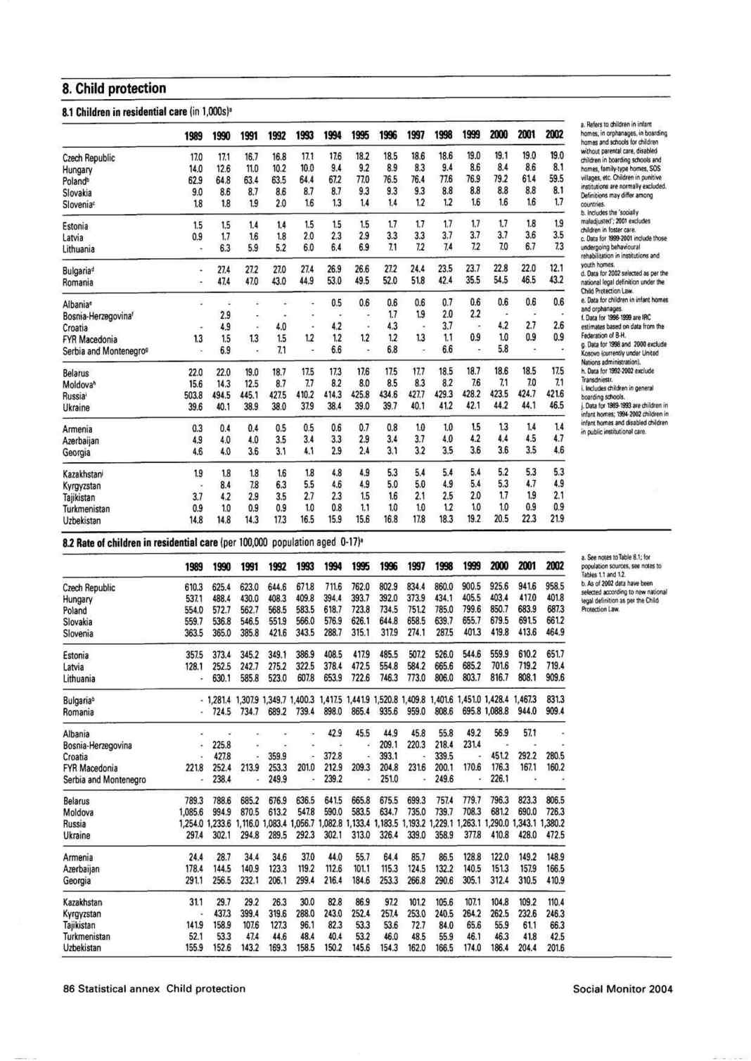
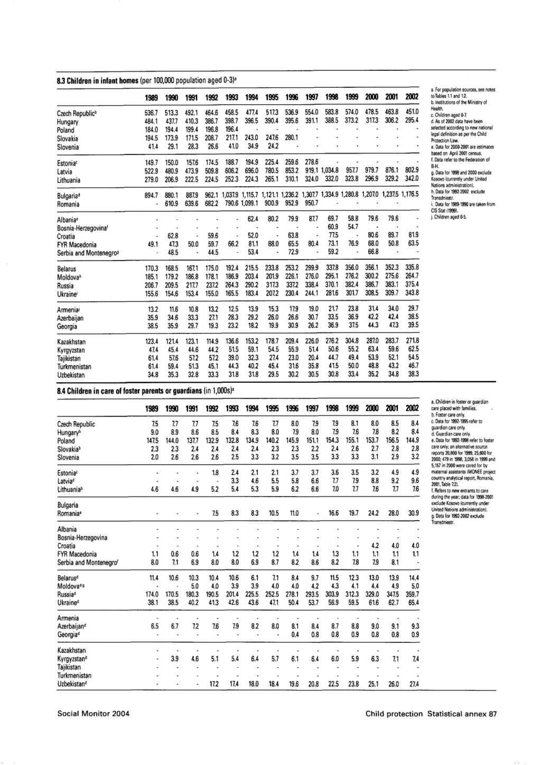
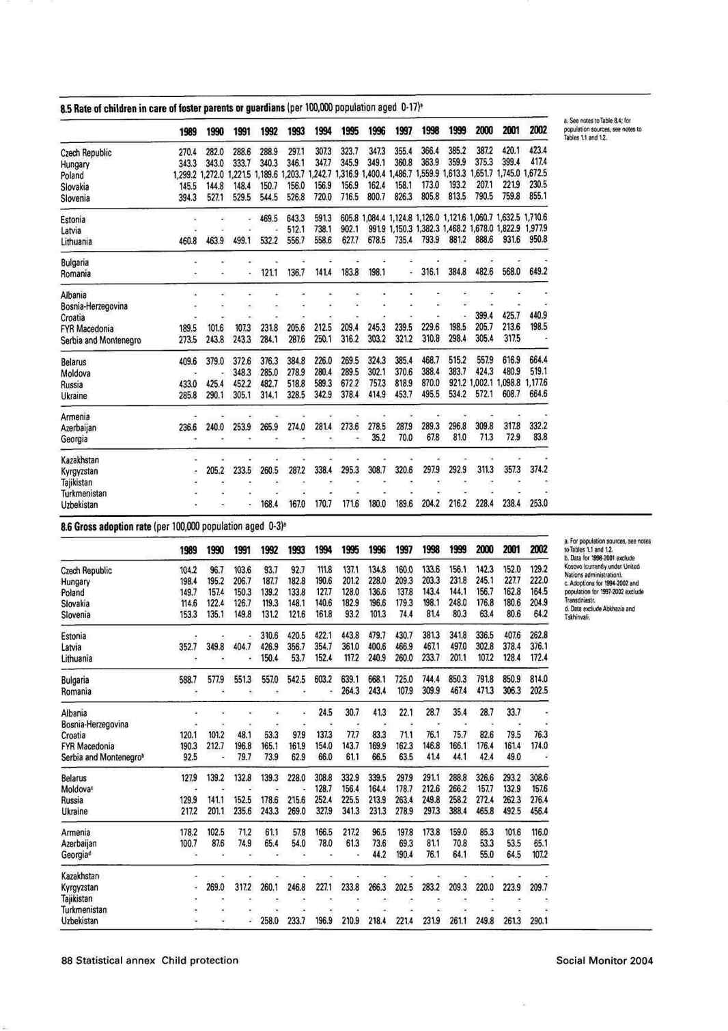
APPENDIX 2 : Programme of the visit to Romania (4 -7 April 2004)

Sunday 4 April Arrival in Bucharest

Monday 5 April

9.30 am Meeting with Ms Gabriela COMAN, State Secretary, Head of the National Authority responsible for child protection and adoptions

11 am Meeting with Mr Gheorghe IANCU, deputy People’s Advocate.

12.30 pm Meeting with Senator Ghiorghi PRISACARU, Head of the Romanian Parliamentary Delegation to the Parliamentary Assembly of the Council of Europe and other members of the delegation.

4 – 6 pm Visit to the Centre for Children with Special Needs, str. Codrii Neamtului, N°4, Sector 3, Bucharest

7.30 pm Dinner hosted by the head of the Romanian Parliamentary Delegation.

Tuesday 6 April

8.30 am Departure for Ploiesti

9.45 am Meeting with Mircea COSMA, leader of Prahova County Council

10.30 am – 6 pm Visit to “Sf. Andrei” rehabilitation centre for severely disabled children, str rapsodiei, N°2, Ploiesti

Visit to the “Window onto the Sun” project, Brebu

Visit of the Placement Center, Sinaïa str. Manastirii N° 11

9 pm Arrival in Bucharest

Wednesday 7 April

9.00 Meeting with Mr Ioan RUS, Home Secretary

10.00 Meeting with Mr O. BRINZAN, Minister for Health

15.00 Press Conference

17.00 End of the official programme

Thursday 8 April

Visit of the Child protection Center, Hunedoara, Deva, str. Iuliu Maniu N° 18
APPENDIX 3 : State-run placement centres in Romania to be closed down shortly under the Phare programme RO01 104.01 01

Crt. No | RO0104.01.01 | Comté | Nom des centres de placement à fermer
1 | B1 342 | Bucuresti sector 1 | Placement center “Sf. Andrei » |  |  |  |  |  | 1
2 | B1 343 | Bucuresti sector 1 | Residential component of Placement Centre “Sf. Escaterina” (former leagan) |  |  |  |  |  | 1
3 | B2 345 | Bucuresti sector 2 | Placement centre Lizuca |  |  |  |  |  |  | 1
4 | B4 350 | Bucuresti sector 4 | Placement center no. 2 “Speranta” (project : Social  Centre “Hope of hope”)
5 | B4 351 | Bucuresti sector 4 | Placement Centre ''Sf. Vasile'' (former leagan) |  |  |  |  |  |  | 1
6 | B4 352 | Bucuresti sector 4 | Placement Center "Sf. Spiridon" |  |  |  |  |  |  | 1
7 | BT 318 | Botosani | Placement Center "Colibri" Botosani (project development of the maternal assistance network) |  |  |  |  |  |  | 1
8 | BT 319 | Botosani | "Sf. Stelian" Placement Center (development of a family type homes network) |  |  |  |  |  |  | 1
9 | BV 368 | Brasov | Placement Centre ''Barza Mica'' - Brasov (former camin spitall) |  |  |  |  |  |  | 1
10 | BV 369 | Brasov | Placement Centre ''Micul Print'' - Brasov (former leagan) |  |  |  |  |  |  | 1
11 | BR 306 | Braila | Placement Centre no 5 "Sfantu Nicolae" Braiala
12 | BZ 303 | Buzau | Placement Centre no.3 (''project: Giving value to the family'') |  |  |  |  |  |  | 1
13 | CV 338 | Covasna | Placement Centre no.1 Targu Secuiesc |  |  |  |  |  |  | 1
14 | GJ 313 | Gorj | Tg.-Jiu Placement Center |  |  |  |  |  |  | 1
15 | GL 365 | Galati | Placement Center “Veronica Micle” Targu Bujor |  |  |  |  |  |  | 1
16 | GL 366 | Galati | Placement Center “Unirea” Galati |  |  |  |  |  |  | 1
17 | GR 370 | Giurgiu | Placement Centre ''Sf. Andrei'' (former leagan) |  |  |  |  |  |  | 1
18 | GR 371 | Giurgiu | Placement Centre ''Sf. Toader'' (former camin spital) |  |  |  |  |  |  | 1
19 | HD 337 | Hunedoara | Placement Centre Uricani |  |  |  |  |  |  | 1
20 | IL 348 | Ialomita | Placement centre no.5 -Slobozia (former boarding for special school) |  |  |  |  |  |  | 1
21 | IL 349 | Ialomita | Placement centre no.1-Slobozia (former leagan) |  |  |  |  |  |  | 1
22 | MS 308 | Mures | Placement Centre no.1 |  |  |  |  |  |  | 1
23 | OT 331 | Olt | Placement Centre ''Prichindel'' (former leagan) |  |  |  |  |  |  | 1
24 | OT 333 | Olt | Placement Centre “Sf.Ioachim si Ana” (former boarding for special school)
25 | SJ 312 | Salaj | "Badacin" Placement Center for disabled children - former camin spital ( project: replacement of residential care with family type alternatice services) |  |  |  |  |  |  | 1
26 | SM 327 | Satu Mare | Placement centre no.14 Pomi |  |  |  |  |  |  | 1
27 | SM 329 | Satu Mare | Placement centre APA (former boarding for special school) |  |  |  |  |  |  | 1
28 | SV 363 | Suceava | Placement Centre Falticeni (alternative services network for Children
9 | VS 355 | Vaslui | Placement Center no 4 Falciu |  |  |  |  |  |  | 1
30 | VS 361 | Vaslui | Placement Center Bogesti |  |  |  |  |  |  | 1

APPENDIX 4 : Programme of the visit to Bulgaria

Tuesday, 24 August, Arrival

Wednesday, 25 August

9.00 Ministry of Justice. Meeting with Mrs Stella ZDRAVKOVA, Director, International Legal Relations /responsible for international adoptions, 1 Slavyanska Str.

10.00 Ministry of Labour and Social Policy. Meeting with Mrs Ivanka Khristova, Deputy Minister

11.00 Ministry of Health. Meeting with Dr Petko Saltchev, Deputy Minister

12.00 Ministry of Education. Meeting with Mr. Youlian NAKOV, Deputy Minister

13.00 Meeting with Mr. Younal LOUTFI, Head of the Bulgarian Delegation to PACE

15.00 Visit to a day care centre in Sofia where children above the age of 16 are being prepared to integrate into society /St Sofia Bridge Project /Zaharna fabrika, Bl. 51A Entr. A/

17.00 Child Protection State Agency. Meeting with Mrs. Vessela BANOVA, Vice President

Thursday, 26 August

9.00 am - 6.00 pm.
Meeting with Mrs Darinka STANTCHEVA, MP, member of the Bulgarian Delegation to PACE and visits to :

- an orphanage in Sofia for mentally handicapped Children : 49 Nikola Petkov Blvd

- an orphanage in Lukovit for physically handicapped children with preserved intellectual abilities, Dom za detza, 54 kniaz Boris I, street

Meeting with Mr O’GORMAN, NGO “Inclusion Europe” (Brussels)

Friday, 27 August

9.00 -13.00
Meeting with representatives of NGOs working in the field of child protection, education, drug prevention, etc. Alexander Battenberg Sq., National Assembly, Hall 134

1. UNICEF, Save the Children, Mrs Laura Parker, Mrs Iva Boneva, Mrs Miglena Baldjieva
2. UNICEF, Sofia, Mrs J. Karaslavova
3. Charity Mother Maria, Mrs Petrana Stoyanova Gateva
4. Every Child, Mrs Rossitsa Borgalinska-Petrova
5. SOS children villages, Mrs Anelia Rogelova
6. Antidot Foundation, Mrs Yana Todorova
7. Step by Step Foundation, Mr Bisser Spirov
8. Animus Association Foundation, Mrs Nadia Kazhouharova
9. Family and drug Foundation, Mr Georges Antonov
10. Alliance for children and youth, Mrs Mariana Pisarska

Meeting with Mr Dimitar DIMITROV, MP, Chair of the Sub-Committee on children’s rights of the Human Rights Committee of the National Assembly,Hall 134.

APPENDIX 5 : Tables of the number of children placed in institutions in Bulgaria

Table of the number of children placed in institutions for 2002 and 2003

MINISTRY OF EDUCATION AND SCIENCE INSTITUTIONS | NUMBER OF INSTITUTIONS FOR 2002 | TOTAL NUMBER OF CHILDREN FOR 2002 | NUMBER OF INSTITUTIONS FOR 2003r. | TOTAL NUMBER OF CHILDREN FOR 2003
TOTAL FOR ALL MINISTRY OF EDUCATION AND SCIENCE INSTITUTIONS | 24 | 23 769 | 234 | 21 837
Homes for upbringing of children deprived of a family environment | 100 | 6 920 | 100 | 6 151
Social educational boarding schools (SEBS) | 20 | 1 988 | 19 | 1 678
Correctional boarding schools (CBS) | 7 | 348 | 6 | 330
SCHOOLS FOR CHILDREN WITH LEARNING DISABILITIES | 78 | 9 529 | 71 | 8 957
RECOVERY SCHOOLS | 23 | 3 430 | 23 | 3 285
SCHOOLS - SANITARIUMS KY) | 5 | 227
EOJIHII9HO Y9IIJImE (KY) | 2 | 207 | 6 | 368
SCHOOL FOR CHILDREN WITH PROBLEMS WITH VOCAL ORGANS | 2 | 89 | 2 | 92
SCHOOL FOR CHILDREN WITH INJURED EYESIGHT | 2 | 331 | 2 | 303
SCHOOL FOR CHILDREN WITH HEARING DISABILITIES | 3 | 647 | 3 | 597
SCHOOL IN HOME FOR BOYS AND GIRLS (NURSERY SCHOOL AND PRIMARY SCHOOL IN LUKOVIT II | 2 | 53 | 2 | 76
Institutions of the municipal submission | NUMBER OF INSTITUTIONS | TOTAL NUMBER OF CHILDREN FOR 2002 | NUMBER OF INSTITUTIONS | TOTAL NUMBER OF CHILDREN FOR 2003
TOTAL OF ALL INSTITUTIONS FOR MUNICIPAL SUBMISSION | 56 | 3 432 | 57 | 3 299
Homes for Children and Adolescents with mental disabilities | 30 | 1773 | 29 | 1 720
DAY CARE CENTERS FOR CHILDREN AND ADOLESCENTS WITH MENTAL DISABILITIES | 16 | 431 | 18 | 463
Social educational and vocational training establishments | 9 | 1147 | 9 | 1 040
HOME FOR CHILDREN WITH PHYSICAL DISABILITIES AND | 1 | 81 | 1 | 76
Comparative table of the number of children placed in specialized institutions on the strength of the Child protection act (2001, 2002, 2003)
Institution’s type | NUMBER OF INSTITUTIONS  2001 | TOTAL NUMBER OF CHILDREN  2001 | NUMBER OF INSTITUTIONS  3A 2002 | TOTAL NUMBER OF CHILDREN  2002R. | NUMBER OF INSTITUTIONS  2003 | TOTAL NUMBER OF CHILDREN 2003
MINISTRY OF EDUCATION AND SCIENCE INSTITUTIONS  Homes for upbringing of children deprived of a family environment | 102 | 7 145 CHILDREN | 100 | 6 920 CHILDREN | 100 | 6 151 CHILDREN
Institutions of the municipal submission  Homes for Children and Adolescents with mental disabilities | 30 | 1 803 CHILDREN | 30 | 1 773 CHILDREN | 29 | 1 720 CHILDREN
Ministry of healthcare institutions  Homes for medical-social care | 32 | 3 563 CHILDREN | 32 | 3 141 CHILDREN | 32 | 3 155 CHILDREN (ACCORDING TO OUR CHECKLISTS ARE 2 906)
Total for all institutions | 164 | 12 511 CHILDREN | 162 | 11 834 CHILDREN | 161 | 11 026 CHILDREN
There is a tendency for reducing the number of children placed in institutions - Since 2001 till the end of 2003 they have been reduced by 11,9 %.
In comparison with 2002, the number of children in Homes for upbringing of children deprived of a family environment has been reduced by 11,1% for 2003.
The number of children in homes for children with disabilities has been reduced by 3% in 2003.
The number of children in Homes for rnedico-social care was constant in 2002 and 2003.
NORMAL MENTAL DEVELOPMENT
Ministry of healthcare institutions | NUMBER OF INSTITUTIONS | TOTAL NUMBER OF CHILDREN FOR 2002ï. | NUMBER OF INSTITUTIONS | TOTAL NUMBER OF CHILDREN FOR 2003.
Homes for medical-social care | 32 | 3 141 | 32 | 3 155  ACCORDING TO OUR CHECKLISTS  ARE 2 906

Table of number of children placed in homes for children and adolescents with mental disabilities and 1 home for children with physical disabilities and normal mental development – 2004
Age | Institution’s type  18 Homes for children and adolescents with mental disabilities and 1 home for children with physical disabilities and normal mental development | Submission  On the municipal submission | Number of children
4-7 |  |  | 56 boys  47 girls
8-11 |  |  | 174 boys  146 girls
12-16 |  |  | 172 boys  158 girls
16-18 |  |  | 72 boys  56 girls
Over 18 |  |  | 142 boys  136 girls

Total number of children :- 1 159
272 children are at the age over 18.

Reporting committee : Social, Health and Family Affairs Committee
Reference to committee: Directive N° 587 (2003)
Draft recommendation unanimously adopted on 17 December 2004
Members of the committee: Mr Marcel Glesener (Chair), Mrs Christine McCafferty (1st Vice-Chair), Mr Ioannis Dragassakis (2nd Vice-Chair), Mrs Patrizia Paoletti Tangheroni (3rd Vice-Chair), Mrs Birgitta Ahlqvist, MM. Giuseppe Arzilli, Mrs Maria Eduarda Azevedo, Mrs Helena Bargholtz, MM. Miroslav Beneš, Andris Berzinš, Jaime Blanco, Bozidar Bojovic, Mrs Marida Bolognesi (Alternate: Mr Rino Piscitello), MM. Dumitru Braghis, Christian Brunhart, Gheorghe Buzatu, Yüksel Çavuşoglu, Igor Chernyshenko, Doros Christodoulides, Mrs Minodora Cliveti, MM. Luis Eduardo Cortès, Thomas Cox, Imre Czinege, Jordi Daban Alsina, Mrs Helen D’Amato, MM. Dirk Dees, Karl Donabauer, Claude Evin, Paul Flynn, Jean-Marie Geveaux, Igor Glukhovskiy (Alternate: Mr Victor Kolesnikov), Tony Gregory, Ali Riza Gülçiçek, Irfan Gündüz, Alfred Gusenbauer, Mykhailo Hladiy, Bent Høie, Mrs Sinikka Hurskainen, MM. Denis Jacquat, Zbigniew Jacyna-Onyszkiewicz, Ramon Jaúregui (Alternate: Mrs Bianca Fernandez-Capel), Andras Kelemen (Alternate: Mr Attila Gruber), Orest Klympush, Baroness Knight of Collingtree (Alternate: Mr Michael Hancock), M. Shavarsh Kocharyan, Ms Katerina Konečná, MM. Slaven Letica, Gadzhy Makhachev, Tomasz Markowski, Mrs Liljana Milićević, MM. Nikolay Mladenov, Philippe Monfils, Mrs Nino Nakashidzé, Mrs Vera Oskina, MM. Janez Padobnik, Marek Pol, Virgil Popa, Francis Poty, Troels Lund Poulsen, Fiorello Provera (Alternate: Mr Francesco Tirelli), Anatoliy Pysarenko, Mrs Valentina Radulović-Šćepanović, MM. Helmut Rauber, Walter Riester, Enrico Rizzi (Alternate: Mr Andrea Rigoni), Mrs Maria de Belém Roseira, Mrs Katrin Saks, MM. Walter Schmied, Samad Seyidov, Mrs Naira Shakhtakhtinskaya, Mr Ossur Skarphédinsson, Mrs Darinka Stantcheva, Mrs Rita Streb-Hesse, MM. Algirdas Sysas, Konstantinos Tassoulas, Mrs Jozephina Topalli, Mr Milan Urbáni (Alternate: Mr Vojtech Tkáč), Mrs Ruth-Gaby Vermot-Mangold (Alternate : Mr Marty), MM. Bart Van Winsen (Alternate: Mrs Marie-Louise Bemelemens-Videc), Mrs Verena Wohlleben, Mr Andrej Zernovski, ZZ..
NB: The names of those members present at the meeting are printed in bold
Head of Secretariat: Mr Géza Mezei
Secretaries of the Committee: Mrs Agnès Nollinger, Mrs Christine Meunier, Mrs Dana Karanjac

