11 April 2014

Dear Roelie,
On behalf of my colleagues at the Global Alliance for Children, I would like to thank you for your participation at the roundtable on Tuesday, co-hosted by Lumos and Claude Moraes. Particularly given the short notice, we were extremely gratified by the level of participation, which demonstrates a broad and deep commitment within the European Commission and other partners to ending the institutionalisation of children across the world. This commitment should facilitate a shift in priorities and funding from institutions towards early childhood development and inclusive community approaches that protect children from violence and ensure they develop to their full potential.
We will be in touch shortly with a summary of the outcomes for the event and, in particular, suggested next steps based on the contributions of participants.

With all best wishes,
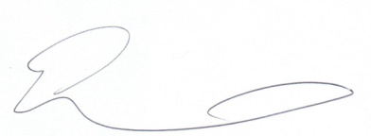

Georgette
............................................................................................
Georgette Mulheir
Chief Executive Officer, Lumos
............................................................................................

